**Leadership Values of Jack Welch**

As everyone knows, the values are playing a key role in leadership. When we study the leadership values of Jack Welch, we find there are four parts of his leadership values: personal leadership styles, eight rules of an excellent leader, values card for GE, and 4E’s of leadership.

**Personal leadership styles1**

There are four words to describe the leadership styles of Jack Welch: authenticity, energy, candor, differentiation.

**Authenticity**: “You have to be yourself, comfortable in your own shoes. People can see through a phony in a minute. People can also see that you’re someone you can count on. In business, people take on a persona that is not really themselves. They feel like they have to conform to some sort of image. That’s just not true.”

**Energy**: “I use “energy” and “energize.” You’ve got to energize people, excite them, bring them on board. Energizing them is hot hyping them, it’s getting them to “feel” the vision, where you’re going. Unless the leader feels the fire, it’s impossible to pass it on. Draw out the people in the room to make you smarter. That’s why you want to hire smarter people. The crazy thing with insecure people is that they hire dopes.”

**CANDOR**: “We fought desperately to get what people really felt on the table. There are huge advantage, and less paperwork. When it comes to meetings, we don’t have to debate about what we’re going to talk about. We know what we’re going to talk about! We’re going to talk about what we think, what we feel.”

**DIFFERENTIATION**: “There’s a ranking of staff; the top 20%, then the vital 70%, and then the 10% back end, lowest performers, etc. Establishing this culture of differentiation, was the best way to lead. Some would say this is a heartless way to treat them. Do you think sports teams differentiate? Do the teams with the best players win? Is winning good? But you can’t have differentiation without candor. You have to have an appraisal system. If you get candor, differentiation, and an appraisal system, that’s really what you want. I don’t know of any leader that can go to work and not know where everybody stands.”

**Eight rules of an excellent leader2**

1. Leaders relentlessly upgrade their team, using every encounter as an opportunity to evaluate, coach and build self-confidence.

2. Leaders make sure people not only see the vision, the live and breathe it.

3. Leaders get into everyone’s skin, exuding positive energy and optimism.

4. Leaders establish trust with candor, transparency and credit.

5. Leaders have the courage to make unpopular decisions and gut calls.

6. Leaders probe and push with a curiosity that borders on skepticism, making sure their questions are answered with action.

7. Leaders inspire risk taking and learning by setting the example.

8. Leaders celebrate!

**Values card for GE3**

Jack Welch created the GE values card ask the employees of GE to carry the card and remember the values all the time.

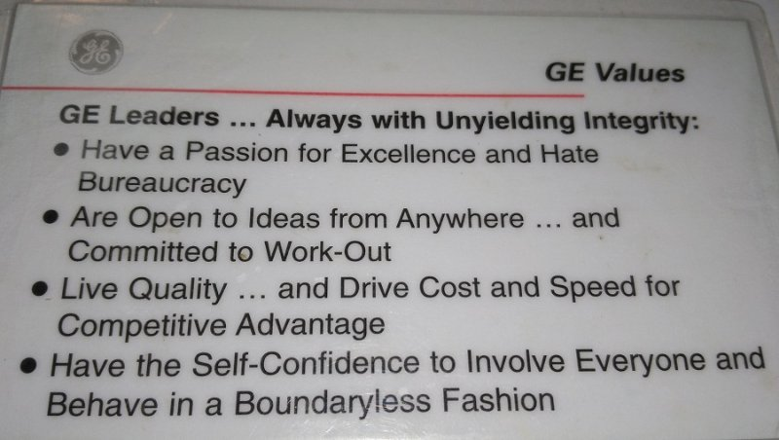

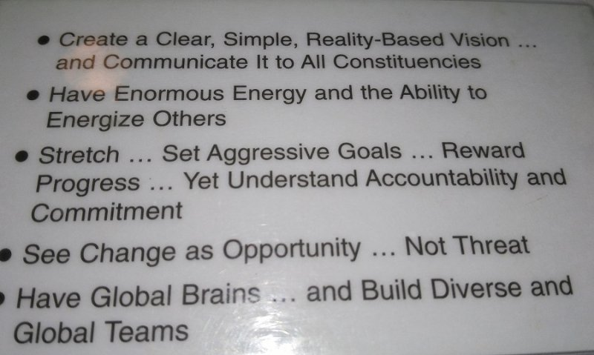

**GE Leaders . . . Always with Unyielding Integrity:**

* Have a Passion for Excellence and Hate Bureaucracy
* Are Open to Ideas from Anywhere . . . and Committed to Work-Out
* Live Quality . . . and Drive Cost and Speed for Competitive Advantage
* Have the Self-Confidence to Involve Everyone and Behave in a Boundaryless Fashion
* Create a Clear, Simple, Reality-Based Vision . . . and Communicate it to All Constituencies
* Have Enormous Energy and the Ability to Energize Others
* Stretch . . . Set Aggressive Goals . . . Reward Progress . . . Yet Understand Accountability and Commitment
* See Change as Opportunity . . . Not Threat
* Have Global Brains . . . and Build Diverse and Global Teams

**4E’s of leadership4**

**Energy** – Individuals with energy love to “go, go, go.” These people possess boundless energy and get up every day ready to attack the job at hand. High energy people move at 95 miles-per-hour in a 55 mile-per-hour world.

**Energizers** – know how to spark others to perform. They outline a vision and get people to carry it out. Energizers know how to get people excited about a cause or a crusade. They are selfless in giving others the credit when things go right, but quick to accept responsibility when things go awry.

**Edge** – Those with edge are competitive types. They know how to make the really difficult decisions, such as hiring, firing and promoting, never allowing the degree of difficulty to stand in their way.

**Execute** – The key to the entire model. Without measurable results, the other “E’s” are of little use. Executers recognize that activity and productivity are not the same and are capable of converting energy and edge into action and results.

Sources:

[1] <https://vialogue.wordpress.com/2010/08/05/leadership-summit-bill-hybels-and-jack-welch-leader-to-leader/>

Leadership Summit 2010 | Bill Hybels and Jack Welch – Leader to Leader

[2] <http://baike.baidu.com/item/WINNING/3971072>

J. Welch and S. Welch, *Winning*, New York: HarperBusiness, 2005.

[3] <https://www.linkedin.com/pulse/wisdom-timeless-ge-values-i-followed-chuck-hall>

J. Welch and John A. Byme, *Jack: Straight from the gut*, 2003

[4] <http://www.refresher.com/jack-welch-and-the-4-es-of-leadership/>

Jeffrey A. Krames, *Jack Welch and the 4E’s leadership*, 2005